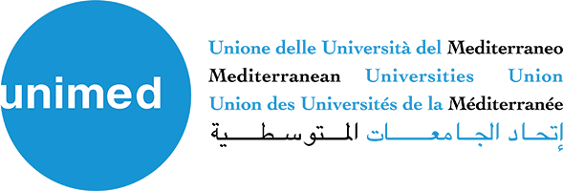
Call for Participation

The Union for the Mediterranean, together with the Catalan Agency for Development Cooperation (ACCD), have launched the project “Women Leading Change: Gender-Responsive Leadership in Mediterranean Universities and Municipalities”.
Universities from Morocco, Lebanon and Syria are invited to express their interest in participating and receiving tailored technical assistance.
This regional project aims to strengthen gender-responsive leadership, institutional reform and collaboration between universities and municipalities, creating sustainable models for inclusive governance and social change in the Southern Mediterranean.
The deadline is 23 January 2026 and all the useful information for the application is available here on the Union for the Mediterranean website :
https://linkprotect.cudasvc.com/url?a=https%3a%2f%2funi-med.us19.list-manage.com%2ftrack%2fclick%3fu%3d4243291f0acf578fb86868a85%26id%3d62f295e610%26e%3d8a4d552c3f&c=E,1,G10D4cuDUNL0fpTwjLTjzeCdW3Uz7sY9wtnfSOaUIyH_NETFPp7RCzadGDnPBq8mu9UvwLxTjywCuGaKJQ0enYZBhV2zM7Oc3LXiPpcFIPZo0THWu4YsuUo,&typo=1
Applications and any questions related to this call should be sent with subject “Women Leading Change Call” by email to: education@ufmsecretariat.org
A total of 10 universities will be selected across the three countries and special attention will be given to universities that demonstrate a strong institutional commitment to gender equality and leadership reform, as well as existing, planned or desired cooperation with their municipality.

