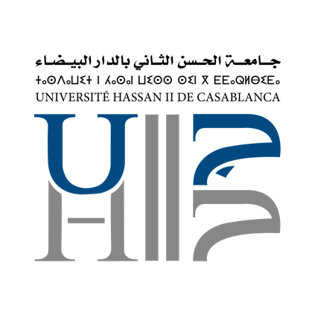

**MOBILITY AGREEMENTS Erasmus+**

**57 MOBILITY AGREEMENTS SIGNED WITH VARIOUS EUROPEAN UNIVERSITIES**

|  |  |  |
| --- | --- | --- |
| **University** | **Country** | **City** |
| Nicolaus Copernicus University in Torun | Poland | Torun |
| University of Szczecin | Poland | Szczecin |
| SİVAS CUMHURIYET UNIVERSITY | Turkey | SİVAS |
| Aksaray University | Turkey | Aksaray |
| UNIVERSITY OF TOKAT GAZIOSMANPASA | Turkey | Tokat |
| Altinbas University | Turkey | Altinbas |
| YOZGAT BOZOK UNIVERSITY | Turkey | Yozgat |
| Bursa Technical University | Turkey | Bursa |
| University of Marmara | Turkey | Marmara |
| Aix Marseille University | France | Marseille |
| Université de Lorraine | France | Nancy |
| INSTITUT PAUL BOCUSE | France | Ecully |
| Université Pierre et Marie Curie | France | Paris |
| Institut national supérieur de formation et de recherche pour l’éducation des jeunes handicapés et les enseignements adaptés | France | Suresnes |
| Metropolitan University Prague | Tchéquie | Prague |
| Palacký University Olomouc | Tchéquie | Olomouc |
| Faculty of Business Economics and Entrepreneurship | Serbia | Belgrade |
| University of Naples Federico II | Italy | Naples |
| University of Bologna | Italy | Bologna |
| Universita’ Degli Studi Di Torino | Italy | Torino |
| Université de Cassino and Southern Lazio | Italy | Cassino |
| University of Pisa | Italy | Pisa |
| Università degli Studi di Napoli "L'Orientale" | Italy | Napoli |
| Sapienza University of Roma | Italy | Roma |
| University of Patras | Greece | Patras |
| Aristotle University of Thessaloniki | Greece | Thessaloniki |
| Royal College of Surgeons | Ireland | Dublin |
| UNIVERSITY OF NATIONAL AND WORLD ECONOMY | Bulgaria | Sofia |
| University of Deusto | Spain | Deusto |
| Polytechnic University of Cartagena | Spain | Cartagena |
| University of Granada | Spain | Granada |
| Universidade de Santiago de Compostela | Spain | Santiago de Compostela |
| University Autonoma of Madrid | Spain | Madrid |
| University of Zadar | Croatia | Zadar |
| Polytechnic Institute of Cavado and Ave | Portugal | S.Martinho |
| Instituco Politecnico do Porto | Portugal | Porto |
| Constantine the Philosopher University in Nitra | Slovak Republic | Nitra |
| Université du Maine le Mans | France | Mans |
| Université D'Angers | France | Angers |
| Université de Rouen | France | Rouen |
| Université Toulouse 3 | France | Toulouse |

|  |  |  |
| --- | --- | --- |
| Kiel University of Applied Sciences | Germany | Kiel |
| RUHR-UNIVERSITAET BOCHUM | Germany | Bochum |
| Eberhard Karls Univeristy of Tübingen | Germany | Tübingen |
| University of Kassel | Germany | Kassel |
| Alexandru Ioan Cuza University of Iasi | Romania | Iasi |
| UNIVERSITY OF AGRICULTURAL AND VETERINARY MEDICINE CLUJ NAPOCA | Romania | Cluj-Napoca |
| Universitatea "Stefan cel Mare" din Suceava | Romania | Suceava |
| West University of Timișoara | Romania | Timisoara |
| POLITEHNICA UNIVERSITY TIMISOARA | Romania | Timisoara |
| University of Bucharest | Romania | Bucharest |
| Lucian Blaga University of Sibiu | Romania | Sibiu |
| Cardiff Metropolitan University | UK | Cardiff |
| Varna Free University "Chernorizets Hrabar" | Bulgaria | Varna |